Applied Microeconomics – Task 1
Ondřej Marvan
477001
- Photographed calculation
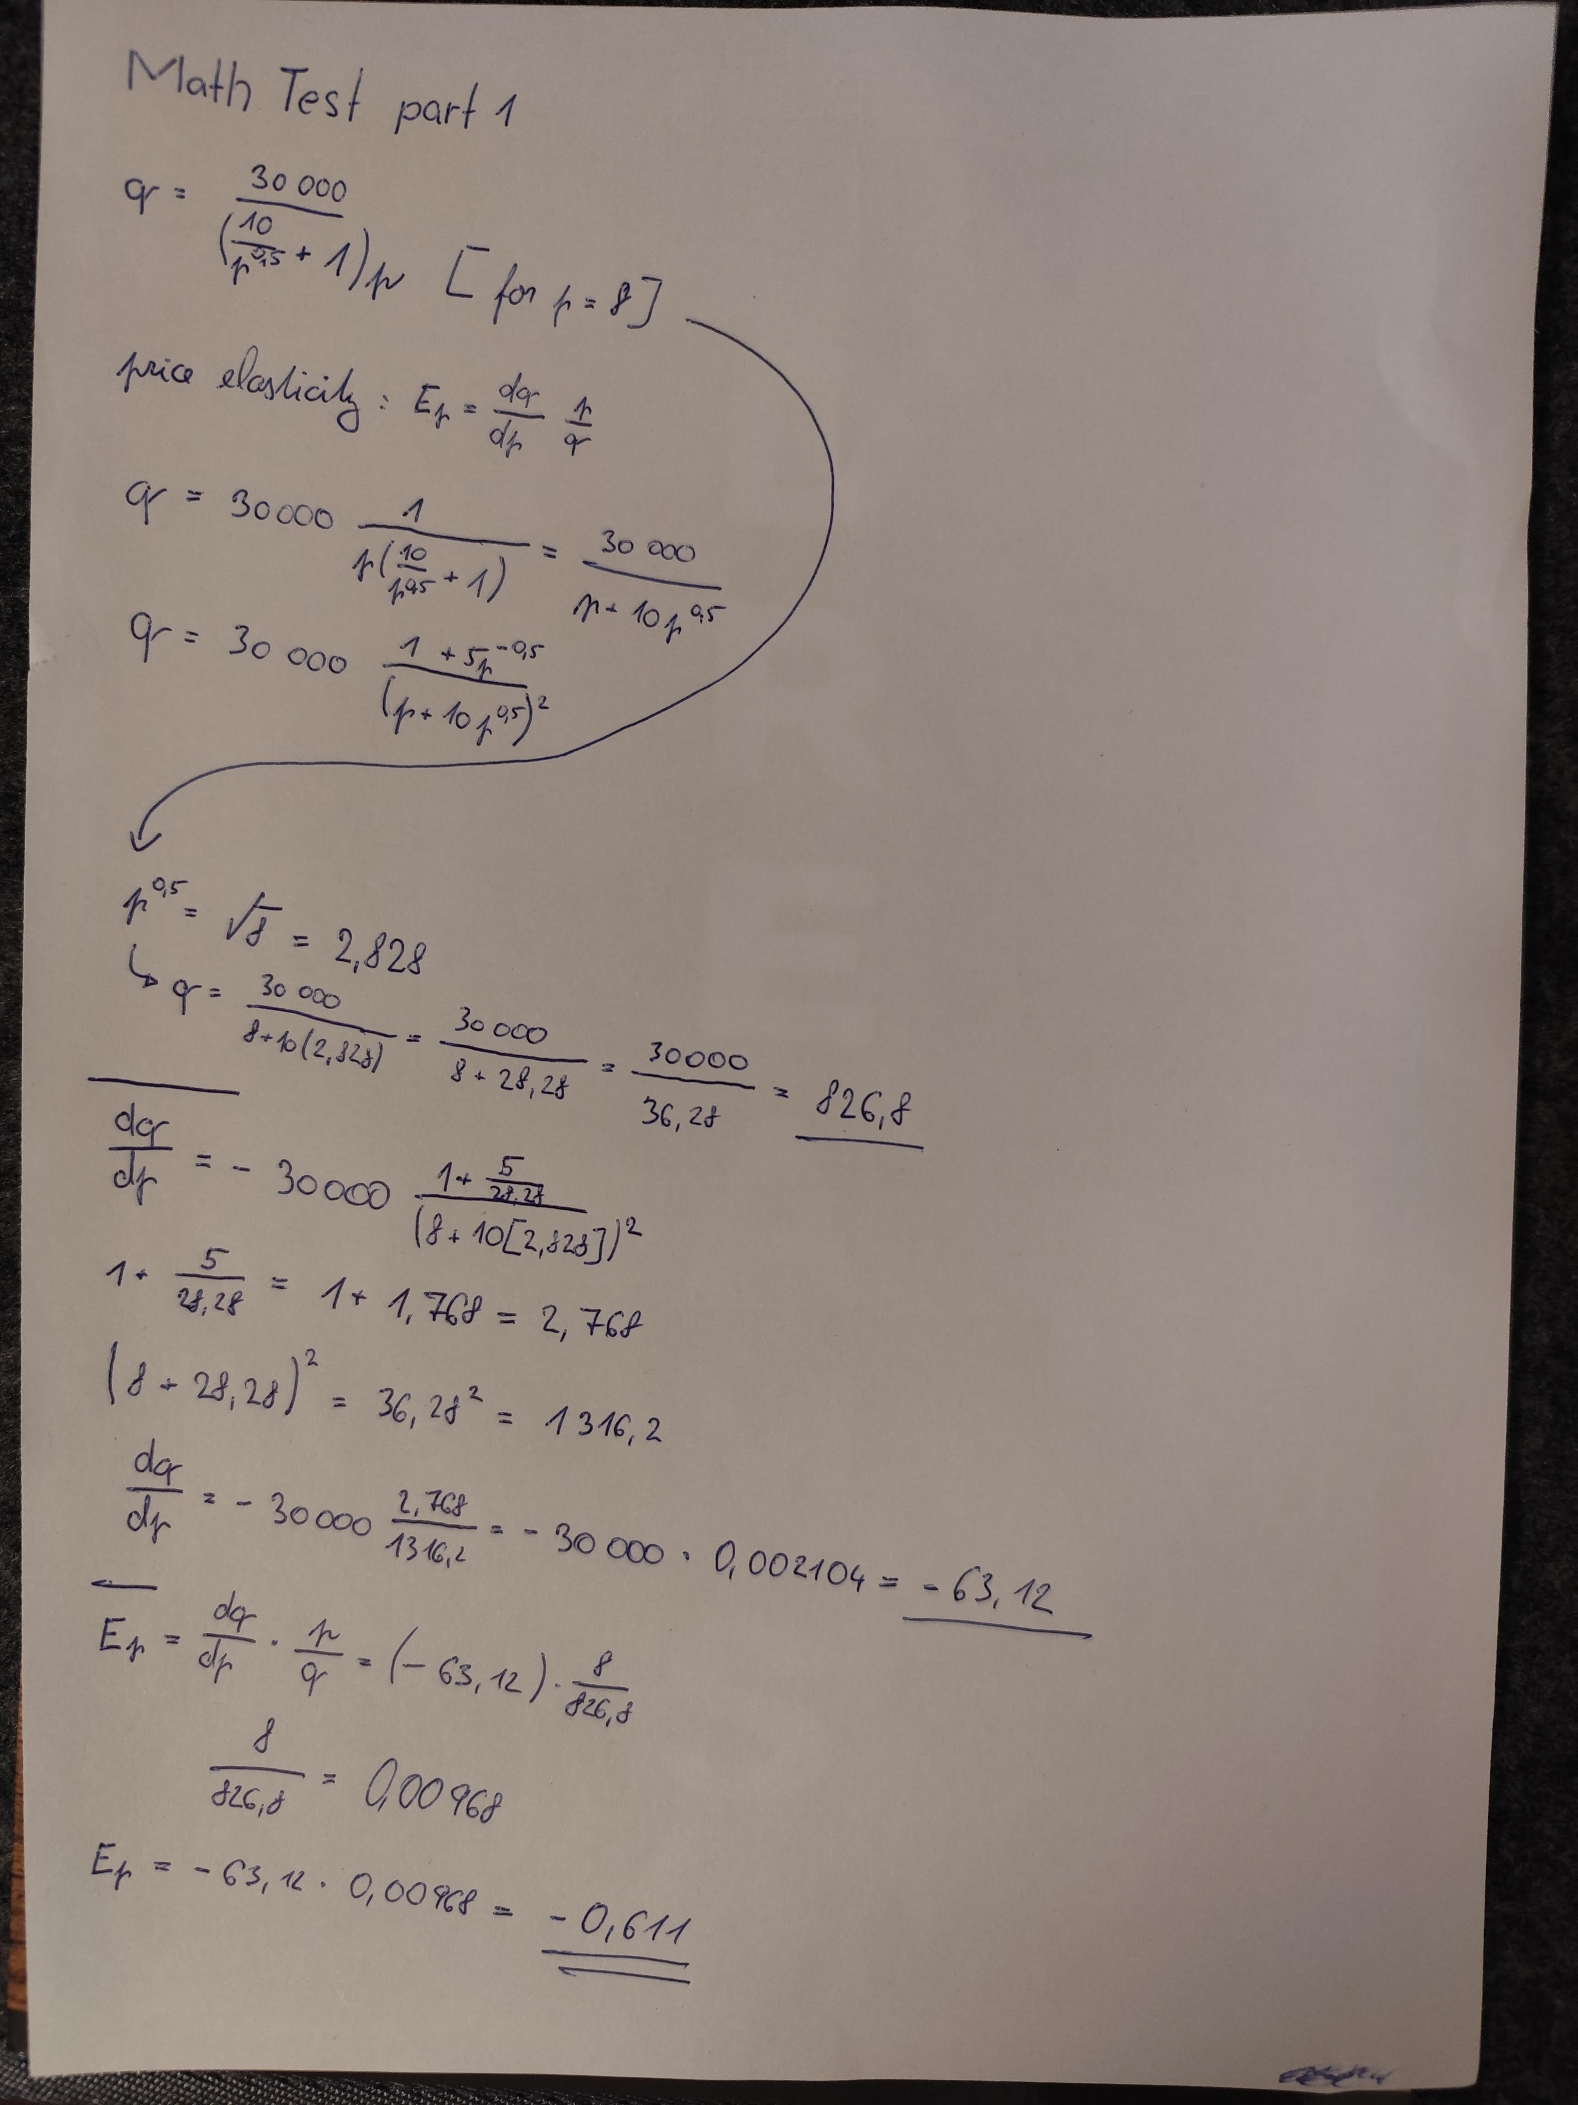
I didn’t do the second calc during the class.

- A short comment - do you think these were difficult calculations, and what is your level of mathematical competence
It took me several attempts and a lot of Googling and revising of math to figure out the correct calculation.

- The result of using the Maxima code, or other IT tool, which is used to calculate this type of task. Provide an interpretation of the result obtained
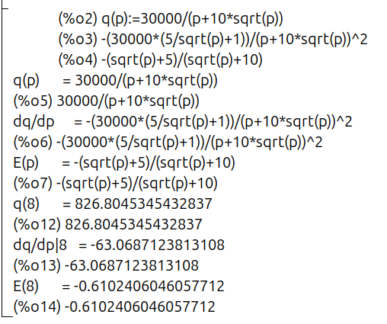

At 𝑝 = 8, the price elasticity of demand is 𝐸_{𝑝} = − 0.61. This means that demand is inelastic — a 1% increase in price would lead to only a 0.61% decrease in quantity demanded. Consequently, total revenue would rise if the price were increased slightly.

Part 2
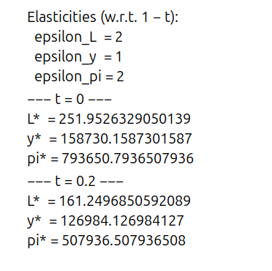
At 𝑡 = 0 t=0, the firm uses about 252 units of labor, makes around 158,700 units of output, and the profit is about 793,651. When the 20% tax is added ( 𝑡 = 0.2 t=0.2), labor drops to 161, output to 126,984, and profit to roughly 507,937. So basically, both labor and profit go down a lot (by about 36%), while output falls by around 20%. It matches the formulas — labor and profit fall with ( 1 − 𝑡 ) 2 (1−t) 2 and output with ( 1 − 𝑡 ) (1−t). The elasticities are 2, 1, and 2, which means if the net-of-tax rate goes down by 1%, labor and profit drop by about 2%, and output by 1%.

